OfS portal
Guidance for user administrators

July 2018

Introduction
The OfS portal is a secure environment for the OfS, Research England and higher education providers to communicate with each other in a variety of ways. Each time we want to communicate confidential information or collect data, we set up a portal ‘area’, specific to a particular process.
Each user of the OfS portal needs a portal user account. These are managed by one or more user administrators at your provider. This has eliminated the need for access keys to join portal areas in most instances, and allows your provider to have control over user accounts and access to areas on the portal. We will continue to send access keys for areas that we consider contain sensitive information.
Your provider should have nominated one or more user administrators to be responsible for the administration of OfS portal accounts and areas. Appointing more than one user administrator can limit the risk of no-one being available to deal with portal requests.
If you do not have a nominated user administrator at your provider, please contact portal@officeforstudents.org.uk.
A user administrator will have, and can grant, access to all areas available on the portal for your provider. This may include data covered by the General Data Protection Regulation, and you should therefore be mindful of the data security issues associated with this role.
A standard portal user will have access to the areas, and associated data, assigned to them by a user administrator.

Nominate a user administrator at your provider
Once you have chosen one or more users to act as user administrators, they will need to join the user administrator area using the access key, which has been sent to the head of provider by post. Once an administrator has access, they can start to manage users and areas for your provider.
The rest of this guide provides instructions for joining the user administrator area and the portal tasks the nominated administrators will need to deal with.

Join the user administrator area
If you are already registered with the OfS portal or were previously registered with the Higher Education Funding Council for England (HEFCE) extranet, you should log in to the portal and click on ‘My account’ followed by ‘Activate an access key’, before entering the access key which will grant access to the user administrator area. This access key was sent by post to your head of provider.
If you have not used the OfS portal or HEFCE extranet before, you will first need to register as follows:
  - Follow the ‘Create an account’ link on the login page (https://extranet.officeforstudents.org.uk/Data).
  - Enter your name and email address and choose a password (at least eight characters, containing upper-case letters, lower-case letters and numbers).
  - Enter the access key.
  - Click the ‘Register’ button.
  - You will be informed whether the registration was successful.
Once you have successfully joined the user administrator area, as an existing or a new user, you will need to log in to https://extranet.officeforstudents.org.uk/Users.

User administrator guide
This guide explains the following functions available to user administrators, which will need to be performed when managing portal accounts and granting access to portal areas.
- Creating a new portal user
- Editing portal user accounts, including unlocking accounts and removing areas
- Assigning areas to a user
- Copying areas from one user to another
- Searching by area and assigning users to areas

A. Creating a new portal user
To access the User administration homepage, you will need to log in to https://extranet.officeforstudents.org.uk/Users with your standard OfS portal username and password.
A1. To create a new user, from the User administration homepage select ‘Create user’.
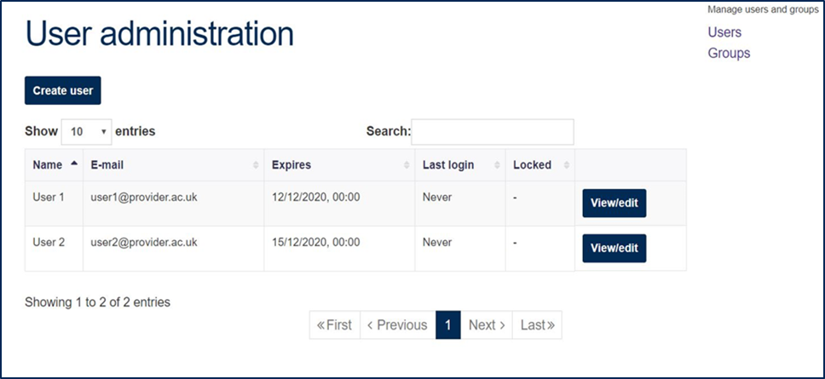
A2. Complete user details and Save.
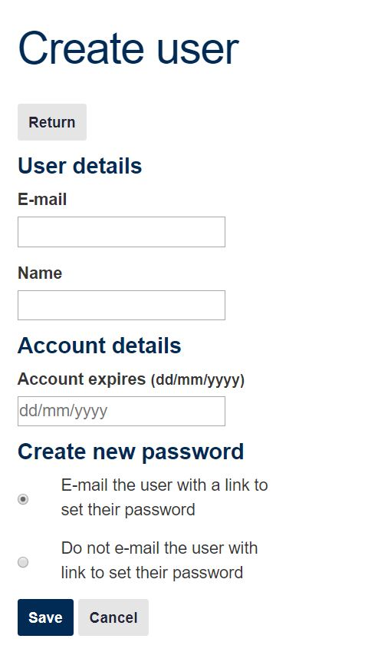
A3. You will receive confirmation that the user has been created. Select ‘Return’ to be returned to the User administration page.
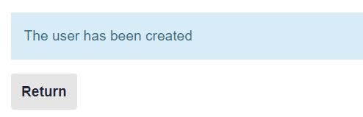

B. Editing portal user accounts, including unlocking accounts and removing areas
B1. From the User administration homepage, find a user by using the ‘Search’ box.
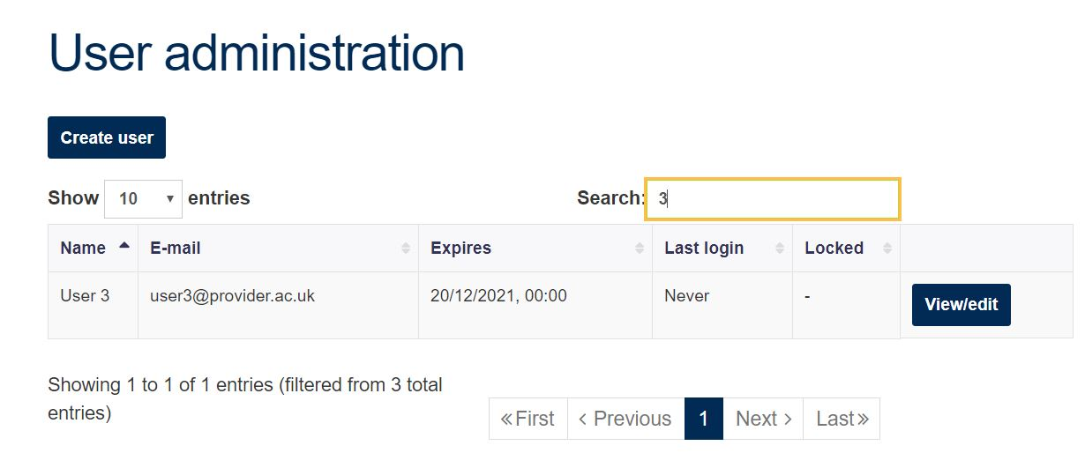
B2. To edit user account details (like email address and name), select ‘View/edit’ for a specific user.
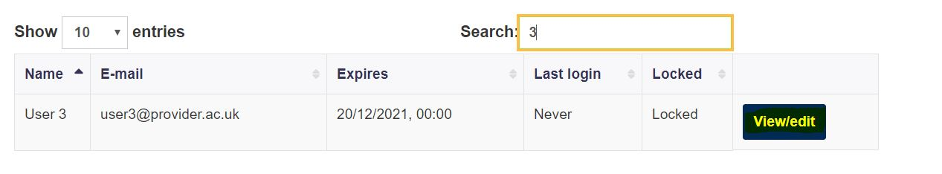
B3. If a user account has become locked (through entering an incorrect password multiple times) or has expired, select Edit.
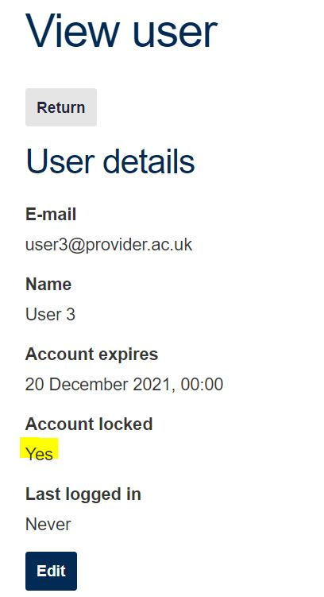
B4. You can then unlock the account or change the expiry date as required.
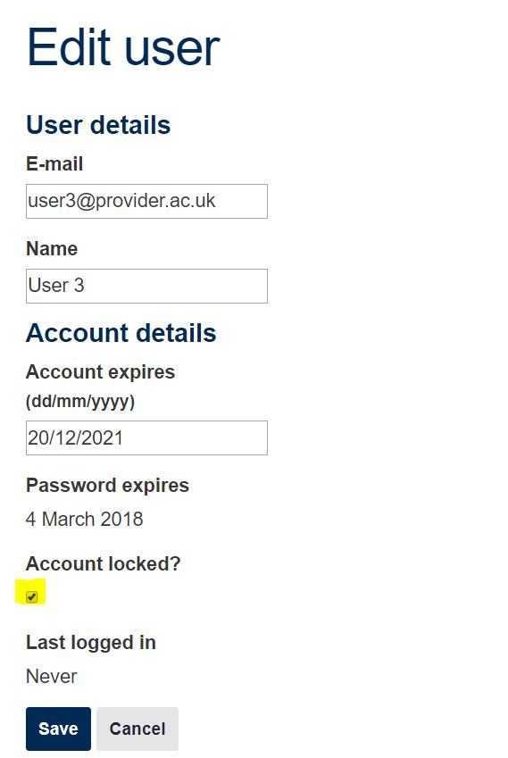
B5. You can remove a user’s access to an area in the ‘Area’ section on the View user page, by selecting ‘remove’ next to the desired area.
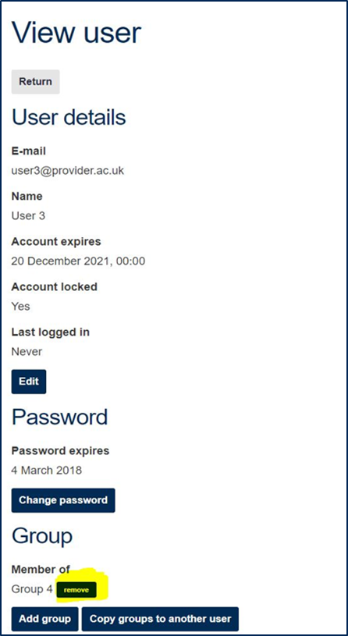
B6. A user account cannot be deleted but the account cannot be accessed after its expiry date has passed. This can be edited, as in B3, to remove access that is no longer required, for example where employees leave a provider.
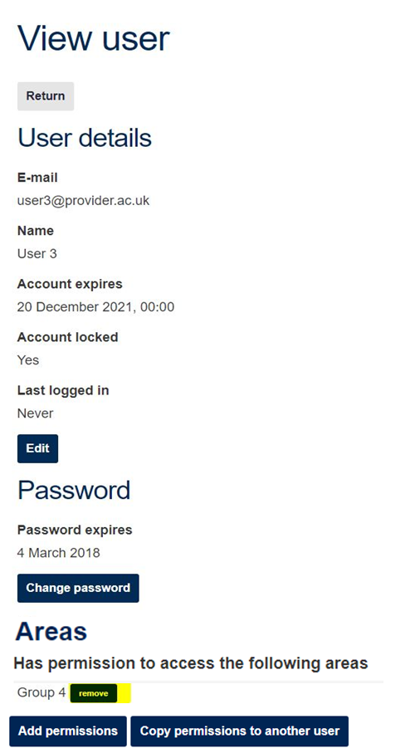

C. Assigning areas to a user
C1. Find a user by using the ‘Search’ box to filter users, then select ‘View/edit’.
C2. From the View user page, scroll down to last section titled Areas, and select Add permissions. From here you can also apply all the user’s areas to other users (see Section D).
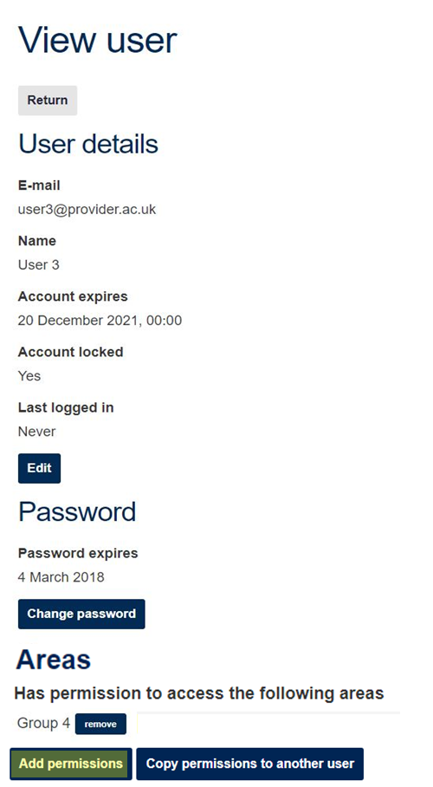
C3. Search and select the appropriate area, then select the ‘Add’ link.
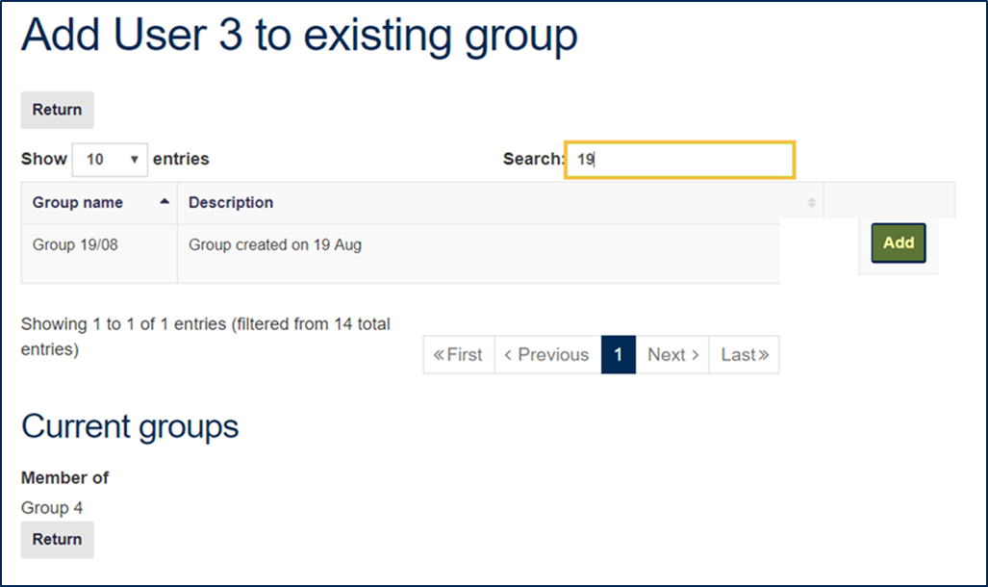
C4. The system will confirm that the user has been added to the area. You can add another area for this user or, once finished, select ‘Return’ to return to the user profile.
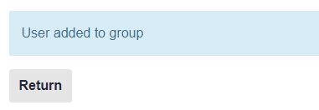

D. Copying areas from one user to another
D1. From View user select ‘Copy permissions to another user’. 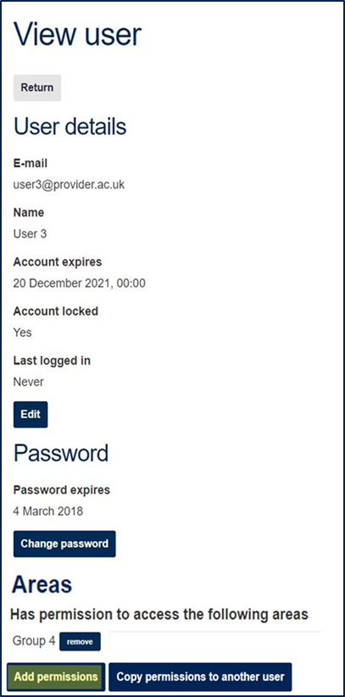
D2. Select ‘Copy to’ for the appropriate user. All the associated areas will be copied.
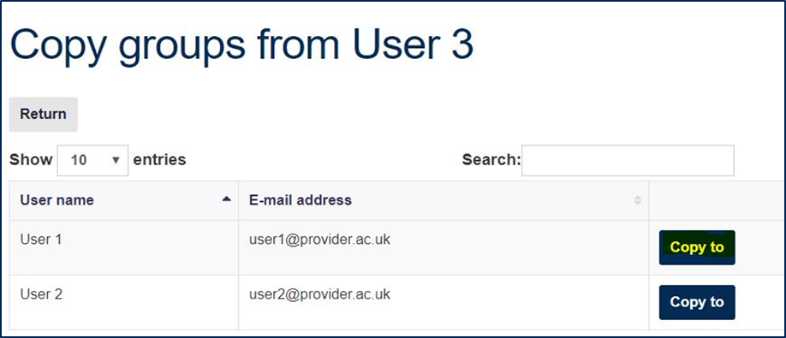
D3. You will see a confirmation that the areas have been copied. Then select ‘Back’ to return to View user.
D4. A user’s access to an area can be removed by following the instructions in B4 (if areas are copied but not all are required for the new user, for example).

E. Searching by area and adding users to an area
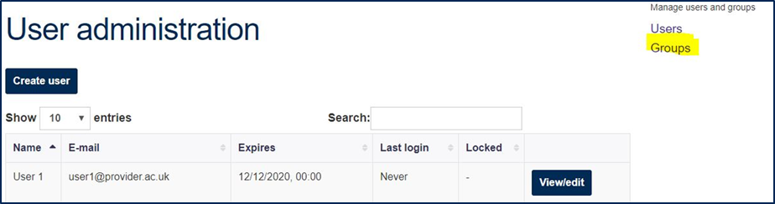
As well as assigning an area to a user, you can also search for an area and then assign users to it from the ‘Areas’ page.
E1. Select ‘Areas’, and then select ‘View’ at the side of the required area.
E2. Select Add users.
E3. Search and select the appropriate user, then select ‘Add’. You can repeat this to add other users to the area. When all required users have been added to the area, use the ‘Return’ link.
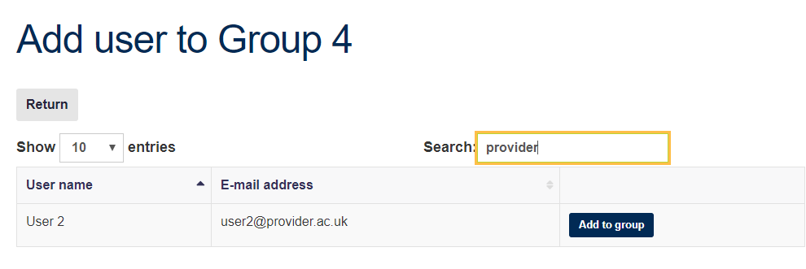

© The Office for Students copyright 2018
This publication is available under the Open Government Licence 3.0.
www.nationalarchives.gov.uk/doc/open-government-licence/version/3/

